* **Assignment 7:** Create a script that takes a text file and replaces all occurrences of "old_text" with "new_text". Use sed to perform this operation and output the result to a new file.

nano replace_text.sh

if [ "$#" -ne 4 ]; then

echo "Usage: $0 input_file old_text new_text output_file"

exit 1

fi

INPUT_FILE=$1

OLD_TEXT=$2

NEW_TEXT=$3

OUTPUT_FILE=$4

sed "s/$OLD_TEXT/$NEW_TEXT/g" "$INPUT_FILE" > "$OUTPUT_FILE"

echo "Replaced all occurrences of '$OLD_TEXT' with '$NEW_TEXT' in '$INPUT_FILE' and saved to '$OUTPUT_FILE'"

chmod +x replace_text.sh

./replace_text.sh input_file.txt old_text new_text output_file.txt



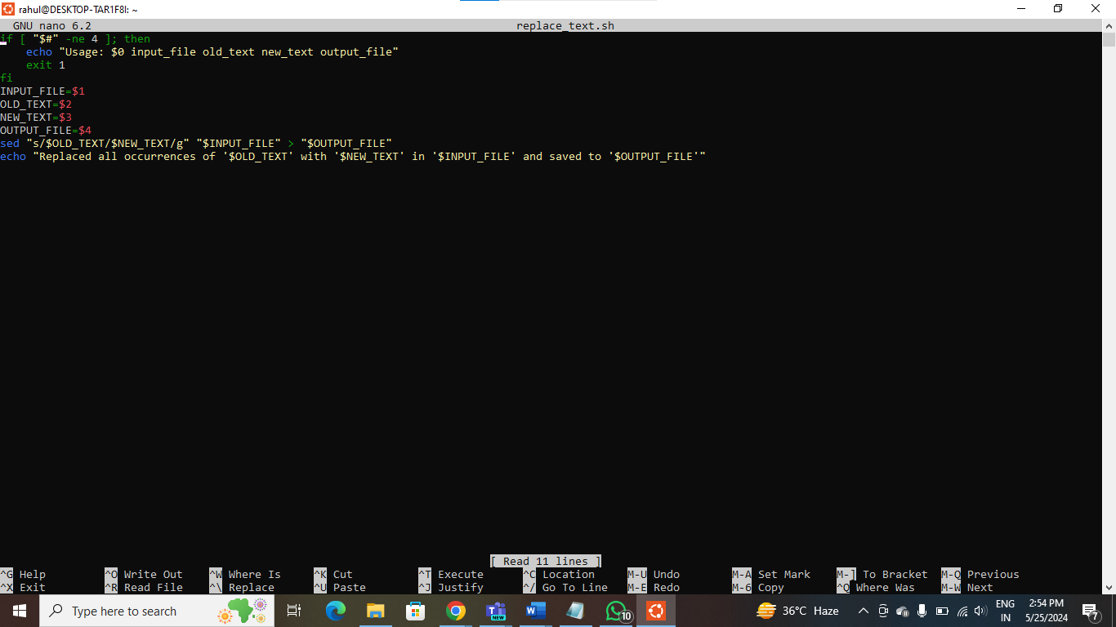

**PRESS CTRL + O , THEN PRESS ENTER, THEN PRESS CTRL + X**

